**What’s an EBS Volume?**

* An EBS (Elastic Block Store) Volume is a network drive you can attach to your instances while they run
* It allows your instances to persist data, even after their termination
* They can only be mounted to one instance at a time
* They are bound to a specific availability zone
* Analogy:Think of them as a “network USB stick”
* Free tier: 30 GB of free EBS storage of type General Purpose (SSD) or Magnetic per month

**EBS Volume**

* It’s a network drive (i.e. not a physical drive)
* It uses the network to communicate the instance, which means there might be a bit of latency
* It can be detached from an EC2 instance and attached to another one quickly
* It’s locked to an Availability Zone (AZ)
* An EBS Volume in us-east-1a cannot be attached to us-east-1b
* To move a volume across, you first need to snapshot it
* Have a provisioned capacity (size in GBs, and IOPS)
* You get billed for all the provisioned capacity
* You can increase the capacity of the drive over time

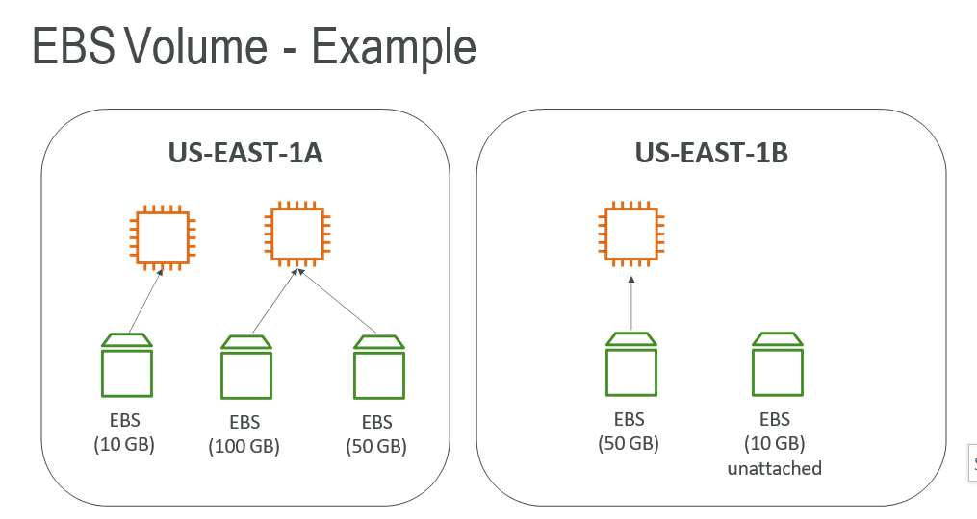

**EBS – Delete on Termination attribute**

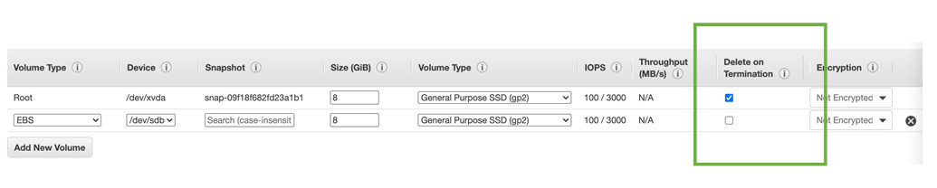

* Controls the EBS behaviour when an EC2 instance terminates
* By default, the root EBS volume is deleted (attribute enabled)
* By default, any other attached EBS volume is not deleted (attribute disabled)
* This can be controlled by the AWS console / AWS CLI
* Use case: preserve root volume when instance is terminated

**EBS Snapshots**

* Make a backup (snapshot) of your EBS volume at a point in time
* Not necessary to detach volume to do snapshot, but recommended
* Can copy snapshots across AZ or Region

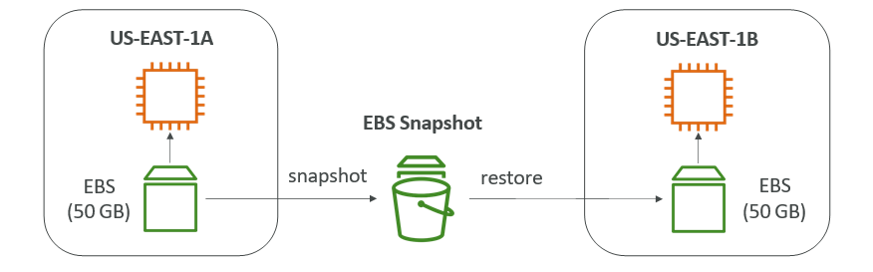

**EBS Volume Types**

* EBS Volumes come in 6 types
  + gp2 / gp3 (SSD): General purpose SSD volume that balances price and performance for a wide variety of workloads
  + io1 / io2 (SSD): Highest-performance SSD volume for mission-critical low-latency or high-throughput workloads
  + st1 (HDD): Low cost HDD volume designed for frequently accessed, throughput- intensive workloads
  + sc1 (HDD): Lowest cost HDD volume designed for less frequently accessed workloads
* EBS Volumes are characterized in Size | Throughput | IOPS (I/O Ops Per Sec)
* When in doubt always consult the AWS documentation – it’s good!
* Only gp2/gp3 and io1/io2 can be used as boot volumes

**EBS Volume Types Use cases General Purpose SSD**

* Cost effective storage, low-latency
* System boot volumes,Virtual desktops, Development and test environments
* 1 GiB - 16 TiB
* gp3:
  + Baseline of 3,000 IOPS and throughput of 125 MiB/s
  + Can increase IOPS up to 16,000 and throughput up to 1000 MiB/s independently
* gp2:
  + Small gp2 volumes can burst IOPS to 3,000
  + Size of the volume and IOPS are linked, max IOPS is 16,000
  + 3 IOPS per GB, means at 5,334 GB we are at the max IOPS

**EBS Volume Types Use cases Provisioned IOPS (PIOPS) SSD**

* Critical business applications with sustained IOPS performance
* Or applications that need more than 16,000 IOPS
* Great for databases workloads (sensitive to storage perf and consistency)
* io1/io2 (4 GiB - 16 TiB):
  + Max PIOPS: 64,000 for Nitro EC2 instances & 32,000 for other
  + Can increase PIOPS independently from storage size
  + io2 have more durability and more IOPS per GiB (at the same price as io1)
* Supports EBS Multi-attach

**EBS Volume Types Use cases Hard Disk Drives (HDD)**

* Cannot be a boot volume
* 125 MiB to 16 TiB
* Throughput Optimized HDD (st1)
  + Big Data, Data Warehouses, Log Processing
  + Max throughput 500 MiB/s – max IOPS 500
* Cold HDD (sc1):
  + For data that is infrequently accessed
  + Scenarios where lowest cost is important
  + Max throughput 250 MiB/s – max IOPS 250

**EBS Multi-Attach – io1/io2 family**

* Attach the same EBS volume to multiple EC2 instances in the same AZ
* Each instance has full read & write permissions to the volume
* Use case:
  + Achieve higher application availability in clustered Linux applications (ex:Teradata)
  + Applications must manage concurrent write operations
  + Must use a file system that’s cluster-aware (not XFS, EX4, etc…)

**EFS – Elastic File System**

* Managed NFS (network file system) that can be mounted on many EC2
* EFS works with EC2 instances in multi-AZ
* Highly available, scalable, expensive (3x gp2), pay per use

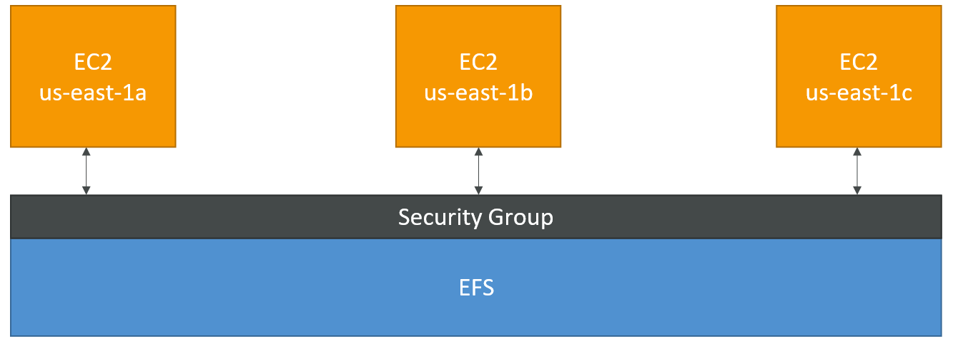

* It is built to scale on-demand to petabytes without disrupting applications, growing and shrinking automatically as you add and remove files
* It is designed to provide massively parallel shared access to thousands of Amazon EC2 instances

**EBS vs EFS – Elastic Block Storage**

**EBS**

* EBS volumes…
  + can be attached to only one instance at a time
  + are locked at the Availability Zone (AZ) level
  + gp2: IO increases if the disk size increases
  + io1: can increase IO independently
* To migrate an EBS volume across AZ
  + Take a snapshot
  + Restore the snapshot to another AZ
  + EBS backups use IO and you shouldn’t run them while your application is handling a lot of traffic
* Root EBS Volumes of instances get terminated by default if the EC2 instance gets terminated. (you can disable that)

**EFS**

* Mounting 100s of instances across AZ
* EFS share website files (WordPress)
* Only for Linux Instances
* EFS has a higher price point than EBS
* Can leverage EFS-IA for cost savings

**EC2 Instance Store**

* EBS volumes are network drives with good but “limited” performance
* If you need a high-performance hardware disk, use EC2 Instance Store
* Better I/O performance
* EC2 Instance Store lose their storage if they’re stopped (ephemeral)
* Good for buffer / cache / scratch data / temporary content
* Risk of data loss if hardware fails
* Backups and Replication are your responsibility